ITA03-MP Assignment 1

L.Vishnu Vardhan Reddy

192372138

CSE(AI)

MOBILE COMPUTING

ASSIGNMENT 1 – CO1
CO1 Coverage: Cellular network concepts; Frequency reuse and interference in cells; Access channels and mobile network capacity; Fundamentals of mobile computing
Nature of Assignment: Individual
Duration: 1 Week
Total Marks: 50
Submission Date: __________________

Assignment Title: Design, Analyse and Optimise a Hexagonal Cellular Network for Spectrum Allocation, Interference Management and Scalable Coverage Planning in a University Township (Total Marks – 50)
Duration:1week

Scenario — Cellular Coverage Planning for a University Township
An operator has been licensed to provide cellular service to a 12 km² university township containing academic blocks, hostels, residential colonies and a main arterial road. The operator holds a fixed allocation equivalent to 336 duplex voice channels (after control-channel overhead) and must plan a hexagonal-cell network. Subscriber demand will grow as the township expands.
You are the radio-planning team. You must investigate how spectrum can be shared across cells, how interference limits that sharing, and how the design must change as the subscriber base grows.

Planning data and constraints
- Subscribers: 1,000 → 10,000 → 20,000 → 100,000+ (planning horizon).
- Average busy-hour traffic per subscriber: 0.025 Erlang. Target grade of service: ≤ 2% call blocking.
- Minimum acceptable SIR: choose and justify a threshold between 12 dB (digital-style) and 18 dB (analogue-style).
- Path-loss exponent n: 2.5 (open campus) to 4 (dense built-up area); justify the values you adopt.
- Spectrum cannot be increased; only the network layout and radio parameters may change.
- Any planning effort (surveys, traffic estimation, number of sites) must be included in your cost analysis.

Answer – Adopted planning assumptions (used in every task below)
The brief leaves several inputs to the planning team. The values below are fixed once here so that every later number can be reproduced.
- SIR threshold γ = 15 dB. Digital receivers need roughly 9–12 dB; analogue ones about 18 dB. I take 12 dB as the receiver need and add 3 dB for effects the first-tier model ignores (second-tier interferers, fading, imperfect antennas). 15 dB sits inside the 12–18 dB range given in the brief.
- Design path-loss exponent n = 3.5. The township is about 30% open campus (n ≈ 2.7) and 70% academic blocks, hostels and colonies (n ≈ 3.8), so the area-weighted value is 0.3×2.7 + 0.7×3.8 ≈ 3.5. Every result is stress-tested at n = 2.5 (open campus) and n = 4 (dense built-up).
- Spectrum and traffic. S = 336 duplex traffic channels (control channels already removed), a = 0.025 Erlang per subscriber, grade of service B ≤ 2% (Erlang-B, blocked calls cleared). Total offered traffic is U × 0.025 Erlang: 25, 250, 500 and 2,500 Erlang for 1,000 / 10,000 / 20,000 / 100,000 subscribers.
- Coverage floor. Coverage, not capacity, fixes the first layout: R₀ = 0.8 km (assumed link budget), so 12 km² ÷ (2.598 × 0.8²) = 7.2, i.e. 8 cells. Capacity then grows by changing R (or splitting), never by adding spectrum.
- Demand shape. Uniform subscriber density unless stated. A hot-spot case is also tested: 70% of demand sits in 3 of the 8 base cells (academic blocks and hostels).
- Sectoring model. With 120° sectors, 2 of the 6 first-tier co-channel cells fall in the main beam (i₀ = 2); with 60° sectors only 1 (i₀ = 1). Channels per sector = ⌊S/(N·K)⌋.
- Cost units (assumed, to be replaced by operator quotes). One macro site per year (build annuity + operation) = 1.0 SE (site-equivalent). 3-sector antennas add 0.2 SE per site; dynamic-assignment measurement hardware adds 0.4 SE per site plus a 2.0 SE central controller. Fixed planning cost = traffic estimation 2.0 SE + propagation survey 0.15 SE/km² × 12 km² = 3.8 SE. Each extra splitting round adds a re-survey of 0.5 SE. A temporary cell-on-wheels (COW) costs 0.02 SE per event day.

Design Challenge (Day 4):
A convocation / sports event will bring 25,000 attendees (0.05 Erlang each) into a 1 km² stadium zone for four hours. Re-evaluate your original design and decide whether to retain, modify or redesign it.

TASK 1 – Design Alternative Frequency-Planning Strategies 5 Marks

Guiding Enquiry
How can a fixed block of spectrum be shared across many cells so that every subscriber is served without intolerable co-channel interference — and in how many fundamentally different ways can this be done?
Investigate and interpret:
- Propose at least three meaningfully different strategies (for example fixed cluster reuse, sectorised reuse, dynamic/borrowed channel assignment, hierarchical macro–micro layering). The same strategy with different cluster sizes (N = 3 vs N = 7) does not count as two strategies.
- At least one strategy must be expressed as an iterative procedure (e.g., searching valid cluster sizes N = i² + ij + j² and assigning channel sets across the grid) and at least one as a recursive/hierarchical procedure (e.g., repeated cell splitting until demand is met).
- analyse the basic idea, the assumptions, and the way the access channels are shared (FDMA/TDMA/CDMA/OFDMA concept and control vs traffic channels).
- Provide pseudocode or a flowchart for each, name the design principle used (spatial reuse, trunking, spatial filtering), and justify why each deserves investigation.
- State the preprocessing required (traffic map, propagation survey, hex-grid layout) and who bears that cost.

Evidence Expected
Three distinct strategies with pseudocode/flowcharts, identified design principle, preprocessing requirements and justification for each.

Answer – Task 1: Four different frequency-planning strategies
How access channels are shared (common to all strategies). The 336 duplex voice channels are modelled as FDMA/TDMA traffic channels: one channel = one carrier–time-slot pair in each direction (for example a TDMA carrier of 8 slots counts as 8 channels). Control channels (broadcast, paging, random access) are carved out beforehand and are never reused inside a cluster. In a CDMA system the same 336-channel budget would be reused in every cell (N = 1) and the SIR limit would appear as soft capacity; in OFDMA the sub-channels play the role of channels and fractional reuse mimics N > 1. The strategies below allocate the traffic channels only.
Strategy | Core idea | Design principle | Procedure type
S1 Fixed cluster reuse | Split S equally over N cells; repeat the cluster over the grid | Spatial reuse | Iterative (search N = i²+ij+j², colour the grid)
S2 Sectorised reuse | Same as S1 but each cell uses K directional sectors, cutting interferers from 6 to 6/K | Spatial filtering | Iterative (search N for each K)
S3 Hierarchical cell splitting | Split overloaded cells into R/2 micro-cells until demand is met; cluster plan N unchanged | Spatial reuse + power scaling | Recursive (SPLIT calls itself)
S4 Dynamic / borrowed channels | Cells draw from a shared pool, or borrow from neighbours, when their own set is full | Trunking efficiency | Event-driven (per call)

S1 – Fixed cluster reuse (iterative)
Basic idea. Find the smallest valid cluster size N = i² + ij + j² whose first-tier SIR meets γ, give each cell of the cluster m = ⌊S/N⌋ channels, and repeat the cluster across the hexagonal grid. Assumptions: uniform traffic, identical cells, first-tier interferers at distance D, n known. Access: FDMA/TDMA channel sets are disjoint inside the cluster; each co-channel cell reuses the same set.
INPUT: S, gamma, n, U, a, R0
FOR N IN sorted({i*i + i*j + j*j : i,j >= 0, N > 0}): # 1,3,4,7,9,12,13,...
Q = sqrt(3*N); SIR = 10*log10(Q**n / 6)
IF SIR >= gamma: N_star = N; (i,j) = pair for N; BREAK
m = floor(S / N_star)
E_cell = ErlangB_inverse(m, 0.02) # Erlang a cell can carry
R = R0
WHILE ceil(Area/(2.598*R^2)) * E_cell < U*a: # capacity check, iterate on R
R = 0.95 * R
FOR each uncoloured cell c (scan order): # colour the hex grid
assign next channel-set id k to c
mark every lattice translate a*g1 + b*g2 of c with id k # g1=(i,j), g2=(-j,i+j)

Why investigate. It is the baseline: simple, no run-time intelligence, and its SIR/capacity trade-off (SIR ∝ N^(n/2), capacity ∝ 1/N) is the yardstick for all other strategies.
S2 – Sectorised reuse (spatial filtering)
Basic idea. Replace each omni antenna by K = 3 (120°) or K = 6 (60°) sector antennas. Interference arrives mostly from sectors that face the mobile, so i₀ drops from 6 to 2 (K = 3) or 1 (K = 6). A smaller N then meets the same γ. Assumptions: ideal antenna patterns, no sector overlap, handoff between sectors of a site. Access: each sector gets ⌊S/(N·K)⌋ channels; trunking is done per sector, so smaller pools lose efficiency.
FOR K IN (3, 6): i0 = 6 / K (2 or 1)
FOR N IN valid cluster sizes ascending:
IF 10*log10(sqrt(3N)**n / i0) >= gamma: BREAK
m_sector = floor(S / (N*K)); E_site = K * ErlangB_inverse(m_sector, 0.02)
sites = ceil(U*a / E_site)
keep (K, N) with the fewest sites that still meets gamma

Why investigate. Sectoring buys SIR without extra spectrum, so it converts directly into a smaller N, but it costs trunking efficiency and handoffs. That trade-off has to be measured.
S3 – Hierarchical cell splitting (recursive)
Basic idea. Start with the coverage-driven layout (R₀ = 0.8 km). Whenever a cell’s load exceeds its 2%-blocking capacity, replace it by four cells of radius R/2 and cut power to P/2ⁿ. Assumptions: the reuse plan N is kept, so D/R and SIR are unchanged; demand is predictable per cell. Access: each new micro-cell receives the same m channels as its parent, so spectrum is reused four times as densely.
def SPLIT(cells, demand, k):
IF capacity(cells) >= demand: RETURN cells, k # base case
over = [c FOR c IN cells IF load(c) > E_cell(c)]
new = []
FOR c IN over:
new += subdivide(c, 4) # four cells, radius R_c/2
power(new cells) = power(c) / 2**n
cells = (cells - over) + new # same N, same m per cell
RETURN SPLIT(cells, demand, k+1) # recurse on the new, smaller problem

Why investigate. It is the classic way to grow capacity when spectrum is fixed, it reuses existing sites, and it is naturally recursive, so Tasks 6 and 7 can solve it exactly.
S4 – Dynamic / borrowed channel assignment (trunking)
Basic idea. Do not bind channels to cells. When a call arrives in a cell whose own set is full, borrow a channel from the neighbour with the most free ones, provided the SIR constraint still holds; the borrowed channel is locked out in the cells that would see it as co-channel. Assumptions: real-time SIR measurement, central or distributed controller, Poisson arrivals. Access: a shared pool of traffic channels (control channels stay fixed).
ON call arrival in cell c:
IF free_own(c) > 0: assign own channel
ELSE:
d = neighbour of c with max free channels
IF free(d) > reserve AND SIR_after_assign >= gamma:
borrow channel from d; lock it in d's co-channel neighbours
ELSE: block the call
ON call end: release channel, unlock the cells it was locked in

Why investigate. Real traffic is uneven in space and time (hostels at night, lecture blocks by day). Pooling raises trunking efficiency exactly where a fixed plan would block.
Preprocessing required and who pays
Strategy | Preprocessing | Cost borne by
S1 | Traffic map (busy-hour Erlang per km²), propagation survey to estimate n, hex-grid layout, site acquisition | Operator (licensee): 2.0 SE traffic + 1.8 SE survey
S2 | S1 plus antenna-pattern measurement and sector azimuth planning | Operator; +0.2 SE per site for antennas
S3 | S1 plus a re-survey and re-optimisation after every round, and power re-tuning | Operator; +0.5 SE per round; township pays for site access/permits
S4 | S1 plus a real-time interference-measurement system and central controller | Operator; +0.4 SE per site + 2.0 SE controller

TASK 2 – Identify the Governing Design Parameter 2 Marks

Guiding Enquiry
For each strategy, which single quantity most strongly controls capacity and interference, and why should the analysis be built around it?
Investigate and interpret:
- Identify the dominant parameter(s) for each strategy (e.g., cluster size N, reuse ratio Q = D/R, number of co-channel interferers, cell radius R, channels per cell).
- analyse where it appears in the strategy and why it is appropriate for efficiency analysis.
- interpret how this quantity must change as subscribers grow from 1,000 to 100,000+.

Evidence Expected
Correct identification and justification of the governing parameter for each strategy, linked to its behaviour.

Answer – Task 2: Governing design parameter
Strategy | Governing parameter(s) | Where it appears | Why it is the right lens
S1 Fixed reuse | Cluster size N (reuse ratio Q = D/R = √(3N)) | Channels per cell m = ⌊S/N⌋; SIR = Q^n/6 | One number sets both capacity (∝ 1/N) and interference (SIR ∝ N^(n/2)); the two move in opposite directions, so the optimum is the smallest N that meets γ
S2 Sectorised | N and the number of interferers i₀ = 6/K (K sectors) | SIR = Q^n/i₀; m = ⌊S/(NK)⌋ | K lowers i₀ and therefore the N required; it is the lever that makes a smaller N legal
S3 Splitting | Cell radius R (equivalently the split level k, R_k = R₀/2^k) | Cells ∝ 1/R²; power P ∝ R^n; handoff rate ∝ 1/R | N is fixed, so SIR is constant; R alone determines how many cells and how much capacity exist
S4 Dynamic | Minimum reuse distance D_min = R(γ·i₀)^(1/n), and the offered-load/channel-pool ratio | Admission test SIR ≥ γ; pooled Erlang-B | Reuse distance is enforced per call instead of per plan, so what limits capacity is load relative to the pool

Growth from 1,000 to 100,000+ subscribers. Offered traffic grows 100-fold (25 → 2,500 Erlang). N cannot shrink below the value fixed by γ and n (see Task 5: N ≥ 7 for omni cells at n = 3.5), so the governing quantity has to move from N to R: with N fixed, cells ∝ 1/R², and R falls from 0.8 km to about 0.2–0.26 km. Sectoring (S2) can reduce N from 7 to 4 where n is high; S4 helps only below the design load. For S1, N stays at 7 while R shrinks; for S3, R halves every round (0.8 → 0.4 → 0.2 km); for S2, N and K are chosen once and R then follows demand; for S4, the pool must be re-planned whenever load/pool nears 1.

TASK 3 – Derive the Capacity and Interference Functions Mathematically 6 Marks

Guiding Enquiry
Starting from hexagonal geometry, how do coverage, capacity and interference depend on the design choices you made?
Investigate and interpret:
- Derive the cluster-size relation, reuse distance D = R√(3N) and reuse ratio Q, hexagonal cell area, and the number of cells needed to cover 12 km².
- Derive channels per cell (S/N), traffic per cell at 2% blocking (Erlang-B reasoning), and total system capacity as a function of N and R.
- Derive the co-channel SIR expression for each strategy (first-tier interferers; effect of sectoring on the number of interferers).
- Combine planning cost (survey, number of sites) with operating capacity to obtain an overall cost–capacity relation for each strategy.
- Show every step; stating a final formula without derivation will not earn full credit.

Evidence Expected
Clear derivations of capacity, number of cells and SIR for each strategy, including planning cost and overall cost–capacity relation.

Answer – Task 3: Capacity and interference derivations
3.1 Hexagonal geometry, cluster size, reuse distance, cells needed
- A regular hexagon of circumradius R splits into six equilateral triangles of side R. Its area is A_c = 6·(√3/4)R² = (3√3/2)R² ≈ 2.598 R².
- The apothem is R√3/2, so adjacent cell centres are d = 2·(R√3/2) = √3 R apart.
- To find the nearest co-channel cell, move i cells along one chain of hexagons, turn 60°, and move j cells. The two moves differ in direction by 120° (interior angle). By the law of cosines: D² = (id)² + (jd)² − 2(id)(jd)cos120° = d²(i² + ij + j²).
Therefore N = i² + ij + j² and D = d√N = R√(3N), Q = D/R = √(3N)
- Valid N: 1, 3, 4, 7, 9, 12, 13, 16, 19, 21 … (checked numerically: for N = 3, 4, 7, 12 the six nearest co-channel cells lie exactly at 3.00R, 3.46R, 4.58R, 6.00R).
- Cells to cover A = 12 km²:
N_c = ⌈A / (2.598 R²)⌉ ≈ 4.619 / R² (R = 0.8 km → 8 cells; R = 0.4 → 29; R = 0.2 → 116)
3.2 Channels per cell, traffic per cell (Erlang-B), system capacity
m = ⌊S/N⌋ (omni), m = ⌊S/(N·K)⌋ per sector
For blocked-calls-cleared traffic with Poisson arrivals and exponential holding, the probability that all m channels are busy is:
B(E, m) = (E^m / m!) / Σ_{k=0}^{m} (E^k / k!) recursion: B(E,0) = 1, B(E,k) = E·B(E,k−1) / (k + E·B(E,k−1))
Setting B(E, m) = 0.02 and solving for E (bisection on the recursion) gives the traffic a cell can carry. Results:
Cluster / sectoring | m (channels per cell or sector) | E per cell/sector at 2% | Trunking efficiency E/m | Subscribers per cell (E_cell/0.025)
N=3 omni | 112 | 99.62 | 0.89 | 3,985
N=4 omni | 84 | 72.53 | 0.86 | 2,901
N=7 omni | 48 | 38.39 | 0.80 | 1,536
N=12 omni | 28 | 20.15 | 0.72 | 806
N=4, 120° | 28 | 20.15 | 0.72 | 2,418
N=7, 120° | 16 | 9.83 | 0.61 | 1,179
N=7, 60° | 8 | 3.63 | 0.45 | 870

Λ(N, R, K) = N_c · K · E(⌊S/(NK)⌋) = (4.619/R²) · K · E(⌊S/(NK)⌋) subscribers supported = Λ / 0.025
For example, N = 7 omni with R = 0.265 km gives N_c = 66 cells and Λ = 66 × 38.39 = 2,534 Erlang, enough for 100,000 subscribers (2,500 Erlang).
3.3 Co-channel SIR for each strategy
- Received power falls as d^(−n). A mobile at distance r from its own base station sees signal r^(−n); each first-tier interferer sits at distance ≈ D.
SIR = r^(−n) / Σ_{k=1}^{i₀} D_k^(−n) ≈ (D/r)^n / i₀ (worst case r = R) → SIR = Q^n / i₀ = (3N)^(n/2) / i₀
- S1 (omni, i₀ = 6): SIR = (3N)^(n/2)/6. Check: N = 7, n = 4 → 21²/6 = 73.5 → 18.66 dB (the textbook 18.7 dB). At n = 3.5: 15.36 dB.
- Exact cell-corner geometry (omni): the six interferers are at D−R (two), D (two) and D+R (two), so SIR_corner = 1 / [2(Q−1)^(−n) + 2Q^(−n) + 2(Q+1)^(−n)]. For N = 7, n = 4 this gives 17.27 dB, about 1.4 dB below the equidistant approximation.
- S2 (sectored): only i₀ = 2 (120°) or 1 (60°) interferers remain, so SIR = Q^n/2 or Q^n. Compared with omni cells, the gain is 10 log₁₀(6/2) = 4.77 dB for K = 3 and 10 log₁₀6 = 7.78 dB for K = 6. N = 7 at n = 3.5 rises from 15.36 to 20.13 dB with 120° sectors.
- S3 (splitting): R′ = R/2 and D′ = D/2, so D′/R′ = D/R. With power P′ = P/2ⁿ the edge signal is P′R′^(−n) = P R^(−n), so SIR is unchanged by splitting.
- S4 (dynamic): a call is admitted only if its measured SIR ≥ γ, so the reuse distance is enforced as D_min = R(γ·i₀)^(1/n). For γ = 15 dB, i₀ = 6, n = 3.5: D_min = 4.48R, i.e. an effective N = Q²/3 ≈ 6.7 (about the same as N = 7). The gain comes from pooling, not from a smaller reuse distance.
- Smallest N that meets γ follows from (3N)^(n/2)/i₀ ≥ γ, i.e. N ≥ (γ·i₀)^(2/n) / 3. With γ = 15 dB = 31.6, i₀ = 6, n = 3.5: N ≥ (189.7)^0.571/3 = 6.67, so the next valid cluster is N = 7. With i₀ = 2: N ≥ 3.6, so N = 4.
3.4 Planning cost and overall cost–capacity relation
Let C₀ be the fixed planning cost (traffic estimation c_t, plus survey c_s per km² times area A), c_site the cost of one site and c_K the extra cost per site of the strategy (sectoring, dynamic hardware). With N_c = A/(2.598R²):
C = C₀ + N_c (c_site + c_K) = (c_t + c_s A) + (c_site + c_K)·A / (2.598 R²)
Because capacity is Λ = N_c · K · E(m), cost is linear in delivered capacity:
C(Λ) = C₀ + [(c_site + c_K) / (K · E(m))] · Λ marginal cost per Erlang = (c_site + c_K) / (K · E(m))
Using the assumed units (3.8 SE fixed; site 1.0 SE; sectoring +0.2 SE; dynamic +0.4 SE per site and +2.0 SE controller), the cost to carry 100,000 subscribers (2,500 Erlang) is:
Strategy | Sites at 100k | Capacity delivered (Erlang) | Total cost (SE) | Marginal cost per Erlang (SE)
S1 N=7 omni | 66 | 2534 | 69.8 | 0.0260
S2a N=7, 120° | 85 | 2506 | 105.8 | 0.0407
S2b N=4, 120° | 42 | 2539 | 54.2 | 0.0199
S4 N=7 omni + borrowing (+8% capacity) | 61 | 2529 | 91.2 | 0.0338
S3 N=7, 120° split twice (uniform) | 128 | 3,774 | 158.4 | 0.0407

The “+8%” for borrowing comes from the simulation in Task 9 (the load at which uniform-demand blocking crosses 2% rises from 1.00 to about 1.08 of design load). S3 has the highest site count only because splitting is discrete (4× steps); its advantage appears under uneven demand (Tasks 6, 7, 11).

TASK 4 – Analyse Best, Average and Worst-Case Behaviour 4 Marks

Guiding Enquiry
Where in the cell, and at what time of day, does each strategy perform best, typically, and worst — and why?
Investigate and interpret:
- Identify the position of the mobile (near the base station, mid-cell, cell corner) that yields best, average and worst SIR, and the geometry of interferers in each case.
- Identify the traffic condition (off-peak, average, busy-hour, event surge) that yields each blocking behaviour.
- analyse how shadowing and a changing path-loss exponent shift each case.
- Support each case with calculations, not just a table of values.

Evidence Expected
Justified best/average/worst analysis for SIR and blocking, supported by mathematical reasoning.

Answer – Task 4: Best, average and worst-case behaviour
4.1 Where in the cell (SIR)
For a mobile at distance r from its own base station and interferers at about D, SIR(r) ≈ (D/r)^n / i₀. The interferer geometry depends on position: near the base station the six interferers are nearly equidistant (≈ D) and weak; at mid-cell they are still ≈ D; at the cell corner the nearest ones are at D−R, the farthest at D+R, and the closest dominate. The calculations below use n = 3.5 and Q = D/R.
Strategy (n = 3.5) | Best: r = 0.1R | Mid-cell: r = 0.5R | Average (Monte-Carlo mean) | Worst: cell corner (exact geometry)
S1 N=7 omni | 50.4 dB | 25.9 dB | 24.1 dB | 14.3 dB
S2a N=7, 120° | 55.1 dB | 30.7 dB | 29.0 dB | 17.9 dB
S2b N=4, 120° | 50.9 dB | 26.4 dB | 24.6 dB | 12.6 dB

Worked example, S1 (N = 7, n = 3.5, Q = 4.583): best = 35·log₁₀(45.83) − 7.78 = 50.4 dB; corner = 1/[2(3.583)^(−3.5) + 2(4.583)^(−3.5) + 2(5.583)^(−3.5)] = 1/0.0376 = 26.6 → 14.25 dB. The sectored corner values use the two dominant interferers at D−R and D: 1/[(Q−1)^(−n) + Q^(−n)]. Important finding: at the true corner, S1 (14.25 dB) and S2b (12.56 dB) fall below γ = 15 dB, while S2a (17.87 dB) still meets it. The “first-tier equidistant” value (15.36 dB for S1) hides this.
4.2 When in the day (blocking)
Offered traffic per sector for S2a (m = 16 channels, 2% load = 9.83 Erlang) at different traffic conditions, using Erlang-B:
Traffic condition | Load as fraction of busy-hour design | Offered load per sector (Erlang) | Blocking
Off-peak (night) | 0.2 | 1.97 | 3.32e-08%
Average day | 0.6 | 5.90 | 0.0281%
Busy hour (design point) | 1.0 | 9.83 | 2%
Busy hour, 20% growth overshoot | 1.2 | 11.79 | 5.56%
Event surge (100k-stage layout, Task 12) | 7.0× density | 50.5 | 69%

Best case = off-peak (blocking essentially zero, about 3×10⁻¹⁰ at 20% load); average = typical day; worst = event surge, where blocking is dominated by the traffic overload rather than interference. Blocking is extremely sensitive near the design point: a 20% overload already pushes the sector from 2% to about 5.6%.
4.3 Effect of shadowing and path-loss exponent
- Path-loss exponent. SIR (dB) = 10 n log₁₀(Q) − 10 log₁₀(i₀), so each unit of n changes SIR by 10 log₁₀Q: 6.6 dB for N = 7 and 5.4 dB for N = 4. For S1 the worst-corner SIR is 8.1 dB at n = 2.5, 14.3 dB at n = 3.5 and 17.3 dB at n = 4. In open campus (n = 2.5) the N = 7 omni design fails γ by 7 dB; in dense areas it has margin. Lower n is the dangerous direction for interference.
- Shadowing. With log-normal shadowing σ = 6 dB on every link, the log-difference of signal and one interferer has a spread of σ√2 ≈ 8.5 dB. The Monte-Carlo runs (same seeds) show the effect for n = 3.5:
Strategy | Mean SIR no shadowing | Mean SIR σ = 6 dB | 5th pct, σ = 6 dB | Outage (SIR < 15 dB), σ = 6 dB
S1 N=7 omni | 24.1 dB | 21.1 dB | 6.6 dB | 28%
S2a N=7, 120° | 29.0 dB | 27.5 dB | 11.8 dB | 10%
S2b N=4, 120° | 24.6 dB | 23.2 dB | 7.2 dB | 22%

Shadowing lowers the mean by 1.4–3 dB and the 5th percentile by 9–10 dB; the sectored N = 7 design is least affected. These outage values are pessimistic because the simulator has no power control or best-server selection (see Task 10).

TASK 5 – Scaling and Sensitivity Analysis 3 Marks

Guiding Enquiry
How do capacity, interference and the number of cells scale as demand and the environment change, and at what point does each strategy stop being practical?
Investigate and interpret:
- Express proportionalities (e.g., capacity ∝ 1/N, SIR ∝ N^(n/2), cells ∝ 1/R²) and compare growth of the strategies.
- Interpret what happens when subscribers grow from 1,000 to 100,000+ and when n varies from 2.5 to 4.
- Identify a break-even scale beyond which a different strategy becomes preferable.

Evidence Expected
Correct scaling relations and an interpretation tied to the township application.

Answer – Task 5: Scaling and sensitivity
5.1 Proportionalities (derived in Task 3)
Quantity | Relation | Consequence
Channels per cell | m = S/N | Capacity per cell falls as N grows (slightly faster than 1/N because trunking efficiency E/m also falls)
System capacity (fixed R) | Λ ∝ 1/N | Halving N doubles total capacity
Cells to cover the area | N_c ∝ 1/R² | Halving R quadruples cells and capacity
SIR | SIR ∝ (3N)^(n/2)/i₀ | Raising n from 2.5 to 4 raises SIR by 10(1.5)log₁₀Q dB: +9.9 dB for N = 7
Transmit power | P ∝ R^n | Halving R cuts power by 2ⁿ (10.5 dB at n = 3.5)
Handoff rate per call | h ≈ 0.735 v/R | Doubles every time R is halved (fluid-flow, hexagon perimeter 6R, area 2.598R²)
Planning cost (sites) | C ≈ C₀ + c·4.619/R² | Cost grows with 1/R²; splitting adds a re-survey per round

5.2 Growth from 1,000 to 100,000+ subscribers
Subscribers | Load (Erlang) | S1 sites (R, km) | S2a sites (R, km) | S2b sites (R, km) | S3 uniform splits (sites)
1,000 | 25 | 8 (0.80) | 8 (0.80) | 8 (0.80) | 8 (k=0)
10,000 | 250 | 8 (0.80) | 9 (0.72) | 8 (0.80) | 32 (k=1)
20,000 | 500 | 14 (0.57) | 17 (0.52) | 9 (0.72) | 32 (k=1)
100,000 | 2500 | 66 (0.26) | 85 (0.23) | 42 (0.33) | 128 (k=2)

Sites are floored at the 8 coverage cells (R = 0.8 km). Sites grow almost linearly with subscribers once capacity-limited: 100× demand needs only about 8–11× more sites for S1/S2 because the initial 8-cell layout is coverage-limited and already carries about 236 Erlang. S2b needs about 40% fewer sites than S1 at 100k (42 vs 66), but only if its SIR holds, and its worst-corner SIR does not (Task 4).
5.3 Sensitivity to the path-loss exponent (smallest valid N meeting γ = 15 dB)
Antenna | n = 2.5 | n = 3.0 | n = 3.5 | n = 4.0
Omni (i₀ = 6) | N = 25 | N = 12 | N = 7 | N = 7
120° sectors (i₀ = 2) | N = 12 | N = 7 | N = 4 | N = 3
60° sectors (i₀ = 1) | N = 7 | N = 4 | N = 3 | N = 3

This is the key sensitivity: in open campus (n = 2.5) an omni plan needs N = 25, which gives only 13 channels per cell, whereas in a dense area N = 7 (or even 4 with sectors) is enough. A single uniform N over the whole township must be set by the worst (lowest-n) zone or protected by sectoring.
5.4 Break-even scales
- Fixed layout without growth: the 8-cell S2a layout carries 236 Erlang; blocking is 1.5% at 9,000 subscribers, 2.9% at 10,000, 31% at 20,000 and 85% at 100,000 (Erlang-B). The first break-even is ≈ 9,500 subscribers, beyond which the base layout must be split or re-tiled.
- Dynamic borrowing vs fixed assignment: in the simulation borrowing cuts blocking from 2.1% to 0.2% at the design load, but at 1.15× design load it is worse (10.7% vs 6.7%) because borrowed channels lock out neighbours. Break-even at ≈ 1.1× design load; above this, fixed plans or splitting win.
- Uniform re-tiling vs splitting: with uniform demand, re-tiling uses fewer sites (85 vs 128 at 100k for S2a) because splitting is discrete (4× steps). With the 70:30 hot-spot demand a uniform tiling must be sized for the hottest cell: 158 sites even if R could be tuned continuously, 512 with 4× splitting, against 272 for selective splitting (ideal cell-by-cell sizing would need 85). Selective splitting wins as soon as the hottest cell needs a higher split level than the average cell (here k = 3 against k = 2).
- Macro to micro hierarchy: below R ≈ 0.25 km (around 100,000 subscribers) antennas drop below roof level, n rises to 4 or more, and a smaller N (or 60° sectors) becomes legal. That is where a micro-cell layer with N = 3–4 becomes preferable to simply splitting an N = 7 macro layout (engineering judgement, to be confirmed by survey).

TASK 6 – Formulate the Recurrence for Repeated Cell Splitting 3 Marks

Guiding Enquiry
If overloaded cells are split repeatedly, how can the number of cells, capacity, transmit power and handoff load after k rounds be expressed in terms of round k − 1?
Investigate and interpret:
- State the original problem size (cells and demand) and the subproblem produced by each split (radius R → R/2).
- Identify the number of new cells per split, the work/cost per round, and the base case (the initial layout).
- Formulate recurrences for number of cells, offered capacity and required transmit power (P′ = P/2ⁿ), derived from your own splitting procedure.
- Allow for selective splitting (only a fraction of cells is overloaded) as well as uniform splitting.

Evidence Expected
Correct recurrence(s) with clearly identified components and base case.

Answer – Task 6: Recurrence for repeated cell splitting
6.1 Problem and sub-problem
- Original problem (round 0): n₀ = 8 cells of radius R₀ = 0.8 km, 24 sectors with 16 channels each (N = 7, 120°). Capacity per cell c = 29.49 Erlang, so C₀ = 8 × 29.49 = 235.9 Erlang (≈ 9,435 subscribers). Demand D(t) = U × 0.025: 25, 250, 500, 2,500 Erlang.
- Sub-problem after one split: every overloaded cell of radius R becomes 4 cells of radius R/2 (area ÷ 4). Each new cell keeps the parent’s channel count m and cluster plan N, so each carries the same c Erlang. 3 new cells appear per split cell (the parent is replaced, a net +3).
- Work/cost per round: W_k = 3 n_{k−1} f_k new sites (f_k = fraction split), each costing c_site (1.2 SE) plus a re-survey r (0.5 SE). Base case: k = 0, the initial layout; n₀ = 8, R₀ = 0.8, P₀ = 1, C₀ = 235.9, h₀ = 1.
6.2 Uniform splitting (all cells split every round)
n_k = 4 n_{k−1} R_k = R_{k−1}/2 C_k = 4 C_{k−1} P_k = P_{k−1} / 2ⁿ h_k = 2 h_{k−1}
Cost: K_k = K_{k−1} + 3 n_{k−1} · 1.2 + 0.5
P_k = P_{k−1}/2ⁿ follows from keeping the edge signal constant: P_k R_k^(−n) = P_{k−1} R_{k−1}^(−n). Handoff rate per call h ≈ 0.735 v/R doubles because R halves.
6.3 Selective splitting (fraction f_k of cells overloaded)
n_k = n_{k−1}(1 + 3 f_k) C_k = C_{k−1}(1 + 3 f_k) (equal-capacity cells) K_k = K_{k−1} + 3 f_k n_{k−1} · 1.2 + 0.5
Power and handoff then differ by cell class: split cells use P/2ⁿ and have doubled h, unsplit cells keep their old values. When different cells split a different number of times, a cell split j times has capacity 4^j c; total capacity is the sum over cells, C_k = Σ_i 4^{j_i} c, and total sites n_k = Σ_i 4^{j_i}.

TASK 7 – Solve the Recurrence and Interpret the Result 4 Marks

Guiding Enquiry
How many splitting rounds are needed to carry the forecast demand, and what do the closed-form results say about cost and mobility?
Investigate and interpret:
- Solve using iteration/substitution (or another suitable method) and justify the method.
- Derive the minimum number of rounds k = ⌈log₄(D/C₀)⌉ for uniform splitting and its selective counterpart.
- Interpret the result: growth in sites, reduction in transmit power, and the increase in handoff rate as radius shrinks.

Evidence Expected
Complete solution with method justification and an interpretation of the closed form.

Answer – Task 7: Solving the recurrence
7.1 Method and closed forms
Each recurrence is first-order, linear and homogeneous, with the previous round as its only input. Repeated substitution (iteration) is therefore the natural method: it is exact, needs no guess, and shows the pattern directly. (The Master theorem does not apply because the problem size is not divided among sub-problems.)
n_k = 4 n_{k−1} = 4² n_{k−2} = … = 4^k n₀ C_k = 4^k C₀ R_k = R₀/2^k P_k = P₀ · 2^(−nk) h_k = 2^k h₀
K_k = K₀ + Σ_{j=1}^{k} (3 · 4^{j−1} n₀ · 1.2 + 0.5) = K₀ + 1.2 n₀ (4^k − 1) + 0.5k
7.2 Minimum number of rounds
Capacity must reach demand: C₀ 4^k ≥ D ⟹ 4^k ≥ D/C₀ ⟹
k = ⌈ log₄(D / C₀) ⌉ (uniform splitting)
For selective splitting with constant fraction f, C_k = C₀(1 + 3f)^k, so
k = ⌈ log_{1+3f}(D / C₀) ⌉
Subscribers | D (Erlang) | D/C₀ | k uniform | Sites 8·4^k | R_k (km) | Capacity (Erlang) | P_k/P₀ at n=3.5 | Handoff ×
1,000 | 25 | 0.11 | 0 | 8 | 0.8 | 236 | 1 | 1
10,000 | 250 | 1.06 | 1 | 32 | 0.4 | 944 | 0.0884 | 2
20,000 | 500 | 2.12 | 1 | 32 | 0.4 | 944 | 0.0884 | 2
100,000 | 2500 | 10.60 | 2 | 128 | 0.2 | 3774 | 0.0078 | 4

For 100,000 subscribers: log₄(10.6) = 1.70 → k = 2. With selective splitting the same demand needs k = ⌈ln 10.6 / ln 1.75⌉ = 5 rounds at f = 0.25 (131 sites), 3 rounds at f = 0.5 (125 sites), 2 rounds at f = 1 (128 sites). Selective splitting needs more rounds, but each round is cheaper and only touches hot cells.
Hot-spot example (70% of demand in 3 of 8 cells). Hot cells carry 583 Erlang each, so they need k = 3 (4³ × 29.5 = 1,887 ≥ 583); the five cold cells carry 150 Erlang, so k = 2. Total sites = 3×64 + 5×16 = 272, against 512 if every cell were split k = 3 times.
7.3 Interpretation
- Sites: grow as 4^k, i.e. as 1/R². Two rounds (R = 0.2 km) bring 8 sites to 128, a 16-fold increase. The 4× step means capacity overshoots: 3,774 Erlang is available against 2,500 needed (51% headroom), which is the price of discrete splitting.
- Transmit power: each round divides power by 2ⁿ: 2^3.5 = 11.3× (10.5 dB). After k = 2 the power is 1/128 of the original at n = 3.5 (−21 dB); −15 dB at n = 2.5 and −24 dB at n = 4. Lower power means smaller interference footprint and longer handset battery life.
- Handoff: h ≈ 0.735 v/R. A vehicle at 30 km/h on the arterial road makes 27.6 handoffs/hour per call at R = 0.8 km and 110 at R = 0.2 km. Handoff signalling load therefore grows 4× in two rounds, so cells on the arterial road should be sectored or umbrella-covered rather than split down to 0.2 km.

TASK 8 – Implement and Test the Planning Strategies 4 Marks

Guiding Enquiry
Can a simulator built from your own strategies reproduce the behaviour predicted by your mathematics?
Investigate and interpret:
- Implement all strategies (e.g., Python/NumPy): hex-grid generator, channel assignment, Monte-Carlo SIR evaluator and Erlang-B calculator.
- Use scaled datasets: 1,000 → 10,000 → 20,000 → 100,000 subscribers with the same random seeds across strategies.
- Include test cases: N = 3, 4, 7, 12; n = 2.5, 3, 4; sectored and unsectored layouts.
- Sanity-check with a known case (N = 7, n = 4 under the six-equidistant-interferer approximation gives about 18.7 dB).

Evidence Expected
Working code, reproducible procedure and correctness checks aligned to the analysed strategies.

Answer – Task 8: Implementation and testing
The simulator is a single Python/NumPy file (cellular_sim.py, delivered with this document). It contains: (1) a hexagonal-grid generator and the co-channel lattice (cells at i·g₁ + j·g₂); (2) channel-set assignment by cluster colouring; (3) a Monte-Carlo SIR evaluator (uniform mobile positions inside a hexagon, first-tier interferers, optional log-normal shadowing, omni/120°/60° sectoring); (4) an Erlang-B calculator and its inverse; (5) an event-driven loss-system simulator for blocking; and (6) a 19-cell network simulator with fixed assignment or channel borrowing with lock-out. Key routines:
def erlang_b(E, m): # recursion, numerically stable
B = 1.0
for k in range(1, m + 1): B = E * B / (k + E * B)
return B

def max_traffic(m, gos=0.02): # inverse Erlang-B by bisection
lo, hi = 0.0, 2.0 * m + 10
for _ in range(60):
mid = (lo + hi) / 2
lo, hi = (mid, hi) if erlang_b(mid, m) <= gos else (lo, mid)
return lo

def mc_sir(N, n, sectors=1, sigma=0.0, trials=20000, seed=1):
i, j = ij_for_N(N); offs = cochannel_offsets(i, j, 1.0)[:6] # first tier
pts = uniform_points_in_hexagon(trials, seed) # mobile positions
ps = dist_to_origin(pts) ** (-n)
pi = dist_to_each(pts, offs) ** (-n)
if sigma: apply 10**(N(0, sigma)/10) to every link
mask = all interferers, or a random 2 (120 deg) / 1 (60 deg) of 6
return 10 * log10(ps / (pi * mask).sum(axis=1))

def loss_sim(E, m, calls, seed): # event-driven M/M/m/m
heap of departure times; block if len(heap) >= m

Reproducible procedure. Every run uses seed = 42 for SIR and 7 (single cell) or 11 (19-cell network) for traffic, so all strategies see the same random streams. Subscriber scales 1,000 → 10,000 → 20,000 → 100,000 are run through the same code path; the offered load is U × 0.025 Erlang. Test grid: N ∈ {3, 4, 7, 12}; n ∈ {2.5, 3, 4}; omni, 120° and 60° sectoring, 20,000 trials each.
Correctness checks (all passed)
Check | Expected | Simulator result
N = 7, n = 4, six equidistant interferers | ≈ 18.7 dB | 18.66 dB
Six nearest co-channel distances for N = 3, 4, 7, 12 | 3.00R, 3.46R, 4.58R, 6.00R | 3.000, 3.464, 4.583, 6.000
Erlang-B: E = 38.39, m = 48 | B = 0.0200 | 0.02000 (inverse routine); event simulation 0.0187 (40k–60k calls, within sampling error)
Erlang-B: E = 9.83, m = 16; E = 20.15, m = 28 | B = 0.0200 | 0.0200; simulated 0.0182, 0.0187
Cells for 12 km² at R = 0.8 km | 4.619/0.64 = 7.2 → 8 | 8
Valid cluster sizes | 1, 3, 4, 7, 9, 12, 13, 16, 19 | identical
Sectoring gain in SIR (analytic) | +4.77 dB (K = 3), +7.78 dB (K = 6) | +4.77 dB, +7.78 dB (N = 7, n = 3.5: 15.36 → 20.13 → 23.14 dB)

Test-matrix results (SIR in dB; analytic = first-tier worst case at the cell edge)
N | n | Omni analytic | Omni sim mean | Omni sim 5th pct | 120° analytic | 120° sim mean | 120° sim 5th pct
3 | 2.5 | 4.1 | 10.2 | 4.7 | 8.9 | 15.1 | 8.7
3 | 3 | 6.5 | 13.8 | 7.1 | 11.3 | 18.7 | 11.0
3 | 4 | 11.3 | 20.8 | 11.6 | 16.1 | 25.9 | 15.4
4 | 2.5 | 5.7 | 11.9 | 6.4 | 10.5 | 16.8 | 10.8
4 | 3 | 8.4 | 15.8 | 9.1 | 13.2 | 20.7 | 13.5
4 | 4 | 13.8 | 23.5 | 14.5 | 18.6 | 28.5 | 18.8
7 | 2.5 | 8.7 | 15.0 | 9.7 | 13.5 | 19.9 | 14.1
7 | 3 | 12.1 | 19.6 | 13.1 | 16.8 | 24.4 | 17.4
7 | 4 | 18.7 | 28.6 | 19.9 | 23.4 | 33.5 | 24.2
12 | 2.5 | 11.7 | 18.0 | 12.7 | 16.4 | 22.8 | 17.2
12 | 3 | 15.6 | 23.2 | 16.8 | 20.3 | 28.0 | 21.3
12 | 4 | 23.3 | 33.4 | 24.8 | 28.1 | 38.3 | 29.3

Each simulated mean sits about 6–10 dB above the edge value because the mobiles are spread over the whole cell; the simulated 5th percentile lies within about 1.5 dB of the analytic edge value, as expected (about 5% of mobiles are in the outer ring).

TASK 9 – Record and Present Experimental Performance 3 Marks

Guiding Enquiry
Which measurements best expose the differences between your strategies, and how should they be presented?
Investigate and interpret:
- Record SIR distribution (mean, 5th percentile), outage probability, blocking probability, channels per cell, sites required and run-time.
- Present tables and plots such as SIR CDFs, blocking vs offered load and capacity vs N.
- Ensure the presentation allows direct comparison between strategies.

Evidence Expected
Systematically collected data presented in comparable tables and graphs.

Answer – Task 9: Recorded performance
Table 9.1 SIR performance (20,000 trials, seed 42)
Strategy | n | Analytic edge (dB) | Mean (dB) | 5th pct (dB) | Outage < 15 dB | Mean, σ = 6 dB | 5th pct, σ = 6 dB
S1 N=7 omni | 2.5 | 8.7 | 15.0 | 9.7 | 62% | 12.0 | -1.1
S1 N=7 omni | 3.5 | 15.4 | 24.1 | 16.5 | 0% | 21.1 | 6.6
S1 N=7 omni | 4.0 | 18.7 | 28.6 | 19.9 | 0% | 25.6 | 10.3
S2a N=7, 120° | 2.5 | 13.5 | 19.9 | 14.1 | 13% | 18.4 | 4.1
S2a N=7, 120° | 3.5 | 20.1 | 29.0 | 20.8 | 0% | 27.5 | 11.8
S2a N=7, 120° | 4.0 | 23.4 | 33.5 | 24.2 | 0% | 32.1 | 15.6
S2b N=4, 120° | 2.5 | 10.5 | 16.8 | 10.8 | 47% | 15.3 | 0.8
S2b N=4, 120° | 3.5 | 15.9 | 24.6 | 16.1 | 2% | 23.2 | 7.2
S2b N=4, 120° | 4.0 | 18.6 | 28.5 | 18.8 | 0% | 27.1 | 10.2

Table 9.2 Capacity, sites, blocking and run-time per subscriber scale (n-independent)
Subscribers | Strategy | Sites | R (km) | Ch. per cell/sector | Offered per cell (Erl) | Blocking, Erlang-B | Blocking, simulated | Run-time (s)
1,000 | S1 | 8 | 0.80 | 48 | 3.1 | 0.00% | — | 0.017
1,000 | S2a | 8 | 0.80 | 16 | 3.1 | 0.00% | — | 0.016
1,000 | S2b | 8 | 0.80 | 28 | 3.1 | 0.00% | — | 0.016
10,000 | S1 | 8 | 0.80 | 48 | 31.2 | 0.12% | — | 0.018
10,000 | S2a | 9 | 0.72 | 16 | 27.8 | 1.35% | 1.43% | 0.016
10,000 | S2b | 8 | 0.80 | 28 | 31.2 | 0.00% | — | 0.016
20,000 | S1 | 14 | 0.57 | 48 | 35.7 | 0.87% | 0.92% | 0.017
20,000 | S2a | 17 | 0.52 | 16 | 29.4 | 1.97% | 2.04% | 0.015
20,000 | S2b | 9 | 0.72 | 28 | 55.6 | 0.94% | 0.93% | 0.016
100,000 | S1 | 66 | 0.26 | 48 | 37.9 | 1.73% | 1.76% | 0.017
100,000 | S2a | 85 | 0.23 | 16 | 29.4 | 1.97% | 2.04% | 0.015
100,000 | S2b | 42 | 0.33 | 28 | 59.5 | 1.76% | 1.77% | 0.016

Where the coverage floor of 8 cells applies (1,000 subscribers and some 10,000 rows), blocking is far below 2% and the simulated column is left blank. Monte-Carlo SIR runs take about 0.01–0.02 s per 20,000 trials; each blocking run (40,000 calls) about 0.02 s; the 19-cell borrowing simulation (120,000 calls) about 0.2 s.
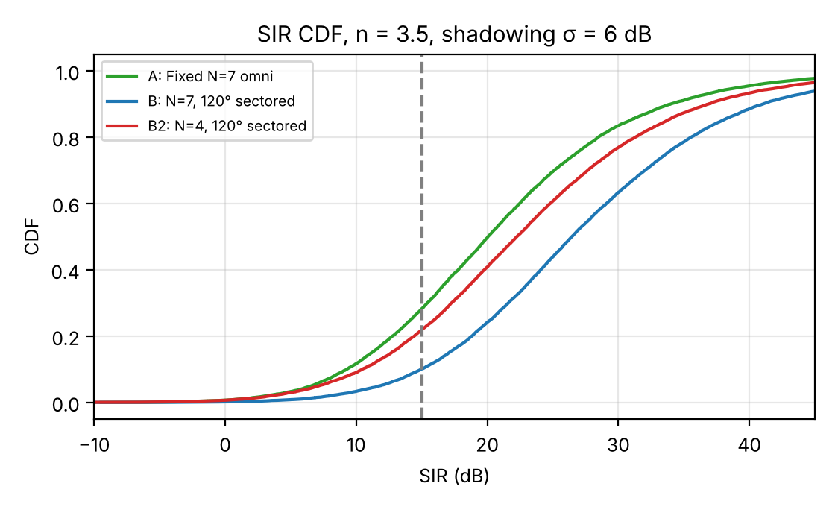
Figure 9.1 SIR CDFs for S1, S2a and S2b (n = 3.5, σ = 6 dB). The dashed line is γ = 15 dB.
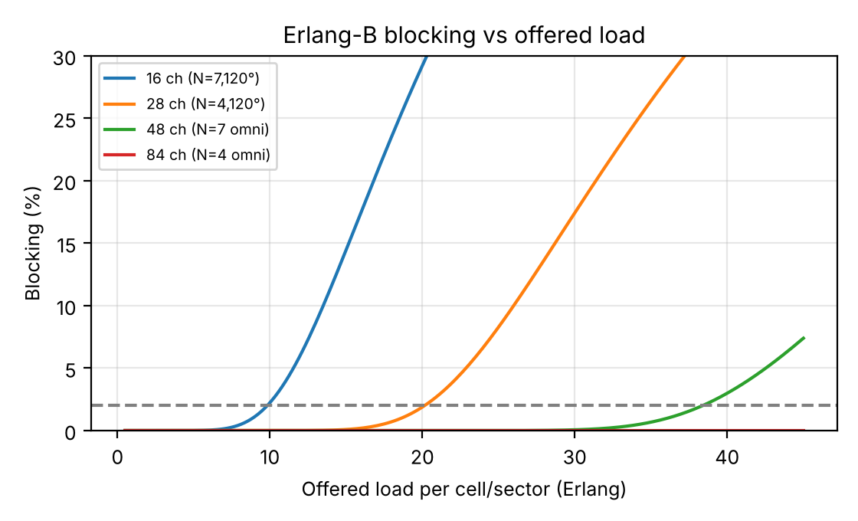
Figure 9.2 Erlang-B blocking vs offered load per cell or sector; the dashed line is the 2% target.
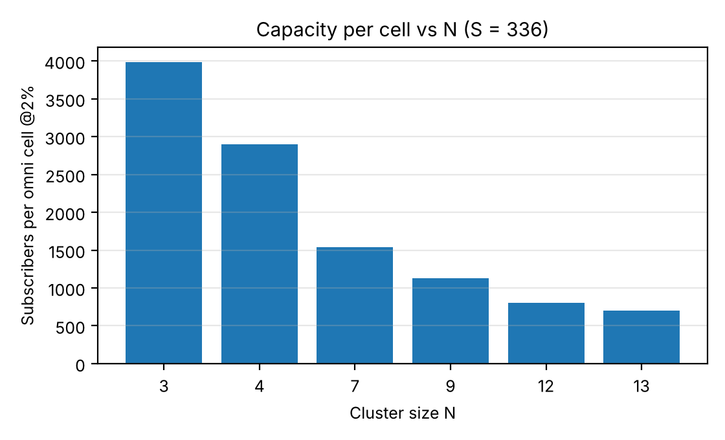
Figure 9.3 Subscribers per omni cell at 2% blocking as a function of cluster size N.
Table 9.3 Fixed assignment vs channel borrowing (19 cells, 48 channels each, 120,000 calls, seed 11)
Mean load / design load | Uniform: fixed | Uniform: borrowing | Hot-spot: fixed | Hot-spot: borrowing
0.50 | 0.00% | 0.00% | 0.63% | 0.00%
0.70 | 0.01% | 0.00% | 5.63% | 0.32%
0.85 | 0.29% | 0.00% | 9.45% | 3.83%
1.00 | 2.10% | 0.22% | 12.55% | 8.20%
1.15 | 6.66% | 10.72% | 15.42% | 13.23%

Hot-spot case: three adjacent cells carry 2.0× and the rest 0.8× of the mean load.
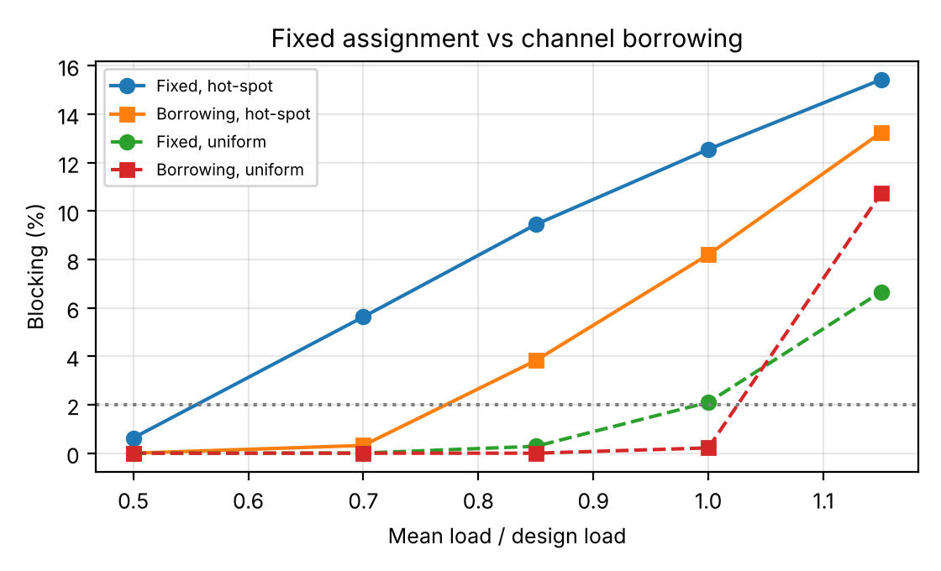
Figure 9.4 Blocking vs load: fixed assignment against borrowing, uniform and hot-spot demand.

TASK 10 – Compare Theory with Simulation 4 Marks

Guiding Enquiry
Where do the simulated results agree with your analytical predictions, where do they differ, and what analyses the gap?
Investigate and interpret:
- Compare analytical and simulated SIR and blocking for each strategy.
- Identify sources of deviation: equidistant-interferer approximation, shadowing, finite tiers, mobile-position distribution, Poisson-arrival and infinite-source assumptions in Erlang-B, integer rounding of N and channels.
- Decide which strategy scales best and defend this using both results.

Evidence Expected
A reasoned comparison of theory and simulation with analyseed discrepancies.

Answer – Task 10: Theory versus simulation
10.1 Agreement and gaps
Quantity | Analytic | Simulated | Gap and cause
S1 SIR, edge, N = 7, n = 3.5 | 15.36 dB (equidistant)  14.25 dB (exact corner) | 5th pct 16.5 dB  mean 24.1 dB | 5th pct is within 1.3 dB of the edge values; mean is 9 dB higher because most mobiles are closer than the edge
S1 SIR with a second tier of interferers | — | mean 24.1 → 23.2 dB  5th pct 16.5 → 15.7 dB | 18 interferers instead of 6 lowers SIR by about 0.9 dB, so the first-tier formula is optimistic
S2a SIR, N = 7, n = 3.5 | 20.13 dB | 5th pct 20.8 dB  mean 29.0 dB | Close agreement; equidistant approximation is slightly pessimistic for the median mobile
Shadowing σ = 6 dB (S1, S2a, S2b) | not in the closed form | mean −1.4 to −3 dB  5th pct −9 to −10 dB | Log-normal spread of 8.5 dB between signal and interferer; closed forms give no distribution
Blocking, 85 sectored sites at 100k | 1.97% (Erlang-B) | 2.04% | Sampling error in 40,000 calls (±0.1%)
Blocking, N = 7 omni, 66 sites at 100k | 1.73% | 1.76% | Same
Blocking at design load, borrowing | Erlang-B gives 2.0% (no borrowing model) | 0.22% uniform, 8.2% hot-spot | Erlang-B cannot represent pooling; simulation is the only estimate

10.2 Sources of deviation
- Equidistant-interferer approximation: all six interferers placed at D overestimates SIR at the corner by 1.1 dB (S1, n = 3.5) and 1.4 dB (n = 4), because real interferers are at D−R, D and D+R.
- Shadowing: raises the spread and lowers the low-percentile SIR by about 10 dB; analytic formulas give a single number, not a distribution.
- Finite tiers: only the first tier is included; a second tier adds about 0.9 dB of interference for the omni case.
- Mobile-position distribution: the analytic value is the cell edge; the simulation averages over a uniform distribution inside the hexagon (users near the base station have 30–40 dB SIR).
- Erlang-B assumptions: Poisson arrivals, infinite source, exponential holding. With 25,000 attendees the infinite-source assumption is nearly true, but event traffic is bursty (calls cluster at the interval), so real blocking would be somewhat higher.
- Integer rounding: N must be a valid cluster size and m = ⌊S/N⌋ drops fractional channels. N = 3, 4, 7 and 12 divide 336 exactly (112, 84, 48, 28 channels), but N = 9 gives ⌊37.3⌋ = 37 and wastes 3 channels, and N = 13 gives 25 and wastes 11. The number of cells is also rounded up, so the real load per cell is slightly below the design value.
- Sectoring model: the simulator keeps a random 2 of 6 (or 1 of 6) interferers; real antenna patterns leak, so real S2 gains are probably 1–2 dB smaller.
10.3 Which strategy scales best
On sites alone, S2b (N = 4, 120°) scales best: 42 sites for 100,000 subscribers against 66 (S1) and 85 (S2a). On robustness, S2a and S3 (which is built on S2a) scale best: S2a is the only plan whose worst-corner SIR (17.9 dB at n = 3.5) meets γ = 15 dB; S2b is 12.6 dB and S1 is 14.3 dB. Dynamic borrowing (S4) reduces blocking by about 10× at and below the design load but becomes worse than fixed assignment above about 1.1× design load, which is exactly where growth takes the network. Conclusion: S3 built on S2a (hierarchical splitting with 120° sectors, N = 7) scales best once both theory and simulation are considered; S2b is a promising upgrade where drive tests confirm n ≥ 3.5.

TASK 11 – Recommend and Defend the Final Design 4 Marks

Guiding Enquiry
Which design would you actually deploy in the township, and what evidence makes it better than the alternatives?
Investigate and interpret:
- State the recommended strategy, parameters (N, R, sectoring) and expected capacity/SIR/blocking.
- analyse why it is superior to the alternatives using your analysis and simulation.
- interpret planning cost, trade-offs (trunking efficiency vs interference, handoff load vs capacity) and limitations.
- Judge whether the design remains practical as the township grows past 100,000 subscribers.

Evidence Expected
A technically justified recommendation supported by analysis and simulation; choosing the highest-capacity option alone is not sufficient.

Answer – Task 11: Recommended design
11.1 The recommendation
Strategy: hierarchical cell splitting (S3) on a 120°-sectored, N = 7 reuse plan (S2a). Parameters: N = 7, K = 3 sectors, 16 channels per sector, R₀ = 0.8 km (8 sites, 24 sectors). Expected performance at n = 3.5: capacity 29.5 Erlang per site (≈ 1,180 subscribers); worst-edge SIR 20.1 dB (analytic), worst-corner 17.9 dB, simulated 5th percentile 20.8 dB; blocking ≤ 2% at design load; SIR unchanged by splitting because power is scaled by 2⁻ⁿ.
Stage | Subscribers | Load (Erlang) | Sites | R (km) | Capacity (Erlang) | Headroom | Power vs R₀ (n=3.5)
0 | 1,000 | 25 | 8 | 0.80 | 236 | 9.4× | 0 dB
1 | 10,000–20,000 | 250–500 | 32 (uniform) | 0.40 | 944 | 1.9–3.8× | −10.5 dB
2 | 100,000 | 2,500 | 128 | 0.20 | 3,774 | 1.5× | −21 dB

11.2 Why it beats the alternatives
Option | Sites at 100k | Worst-corner SIR (n=3.5) | Robust to demand skew / events | Verdict
S1 N=7 omni | 66 | 14.3 dB (< 15) | No (uniform tiling) | Fails γ at the corner and in open campus (n = 2.5: 8.1 dB)
S2b N=4, 120° | 42 | 12.6 dB (< 15) | No | Fewest sites but fails γ at the corner; 22% outage with shadowing
S4 borrowing | 61 | as S1 | Partly, only below 1.1× load | Worse than fixed above design load
S3 on S2a (recommended) | 128 (85 re-tiled; 272 under 70:30 skew) | 17.9 dB (≥ 15) | Yes: splits only where needed | Passes γ with a margin of 2.9 dB at the corner; reuses sites; handles hot spots

The highest-capacity-per-site option (S2b) is not recommended: simulation and the exact-corner calculation both show it fails the SIR threshold at n = 3.5 (outage 22% with shadowing), and at n = 2.5 its outage is 51%.
11.3 Planning cost, trade-offs and limitations
- Planning cost (assumed units): initial 3.8 + 8 × 1.2 = 13.4 SE; at 100,000 subscribers 3.8 + 1.0 (two re-surveys) + 128 × 1.2 = 158.4 SE, about 0.042 SE per Erlang of capacity delivered (0.063 SE per Erlang actually offered). That is 2.9 times the cost of S2b (54.2 SE) and 2.3 times S1 (69.8 SE). The extra cost buys the 2.9 dB corner-SIR margin, 51% headroom up to about 151,000 subscribers, and the ability to split only hot cells. If the operator re-tiles with a continuously adjustable R instead of splitting, S2a costs 105.8 SE for 85 sites, but then loses the splitting advantages.
- Trunking efficiency vs interference: sectoring splits 48 channels into three groups of 16 and lowers E/m from 0.80 to 0.61; the design carries 29.5 Erlang per site instead of 38.4, a 23% loss, in exchange for 4.8 dB of SIR.
- Handoff load vs capacity: two splitting rounds quadruple the handoff rate per call (R halves twice) and raise cells 16-fold. Fast-moving traffic on the arterial road should be handled by sectoring or umbrella cells rather than by splitting to 0.2 km.
- Limitations: idealised hexagonal geometry; first-tier interference only; no power control or handoff-based best-server selection in the simulator; uniform mobiles inside each cell; assumed (not quoted) unit costs; sectoring modelled by interferer count.
11.4 Beyond 100,000 subscribers
After two rounds the design carries 3,774 Erlang ≈ 151,000 subscribers. Practical limits then appear: a third round (512 sites, R = 0.1 km, up to ≈ 604,000 subscribers) raises handoff rate 8× and the power falls 32 dB, so cells would be small outdoor micro-cells at street level where n ≈ 4 or more. At that point the plan should change to a micro-cell layer with N = 3–4 (SIR at n = 4: 18.6 dB for N = 4, 120°) and keep the macro layer for coverage and fast users. The design remains practical to roughly 150,000 subscribers and extends with that change.

DAY-4 DESIGN CHALLENGE

TASK 12 – Re-evaluate and Adapt the Design 8 Marks

Changed Requirement
A convocation / sports event will bring 25,000 attendees, each generating 0.05 Erlang, into a 1 km² stadium zone for four hours. Outside the event, demand stays as originally forecast. Event days occur roughly twice a month.
Re-evaluate your original design under the changed conditions.
You may:
RETAIN → MODIFY → or REDESIGN
your original solution.

A. Impact Analysis – 2 Marks

Guiding Enquiry
What exactly has changed, and which of your original assumptions no longer hold?
- Estimate the new offered traffic density and compare it with the design density.
- Identify affected assumptions (uniform traffic, steady demand, permanent capacity).
- analyse why the short duration and predictability of the surge matter for the choice of solution.

Evidence Expected
A clear analysis of how the surge affects the original design.

Answer – Task 12A: Impact analysis
- New offered traffic. 25,000 attendees × 0.05 Erlang = 1,250 Erlang in 1 km², on top of the ordinary demand in that area. At the 100,000-subscriber forecast the normal density is 2,500/12 = 208 Erlang/km², so the zone now carries 1,458 Erlang/km², 7.0× the design density. At the 20,000-subscriber stage (42 Erlang/km²) the ratio is 31×.
- Against installed capacity. The recommended 100k layout (128 sites, 3,774 Erlang over 12 km²) has an average capacity density of 314 Erlang/km² at 2% blocking, so the event zone needs 1,458/314 = 4.6× what the design provides there.
- Assumptions that no longer hold: (1) uniform traffic: the event is a point load, 7–31× the average; (2) steady demand: the load exists for four hours and then vanishes; (3) permanent capacity: sizing capacity for the peak would leave it idle almost always. Per-attendee traffic is also twice the busy-hour norm (0.05 vs 0.025 Erlang).
- Why duration and predictability matter. Events last 4 h, twice a month, so the surge occupies about 8 h out of 720 h per month, or 1.1% of the time, and it is scheduled weeks ahead. A short, predictable peak favours temporary, relocatable capacity (cells on wheels, a pre-planned frequency plan switched on for the event) over permanently built sites that would be idle 98.9% of the time.

B. Evaluation of the Original Design – 2 Marks

Guiding Enquiry
How would your recommended design behave on event day?
- Estimate blocking probability and interference problems in the stadium zone using your own model.
- Assess whether the design can be reused unchanged and what fails first.
- Identify whether an alternative strategy handles the surge more economically.

Evidence Expected
A technically supported evaluation of the original design under the surge.

Answer – Task 12B: Evaluation of the original design
Offered load per sector is the zone’s total traffic divided by the number of cells in 1 km² and by 3 sectors, with 16 channels per sector; the blocking comes from Erlang-B.
Design stage | Cells in 1 km² | Zone capacity at 2% (Erlang) | Offered event load (Erlang) | Offered per sector | Blocking
20k-stage (R=0.4 km) | 2.4 | 71 | 1292 | 179.0 | 91%
100k-stage (R=0.2 km after 2 splits) | 9.6 | 284 | 1458 | 50.5 | 69%

- Blocking: about 91% at the 20,000-subscriber stage and 69% at the 100,000 stage; only about 31% of call attempts succeed. The 100k layout can carry 284 Erlang in the zone against 1458 offered.
- Interference: the SIR design already assumes that every co-channel cell is fully busy, so the SIR analysis is not changed by the surge (20.1 dB analytic at n = 3.5). What does change is that every channel in the stadium cells is permanently busy, so the worst-case interference is the normal case, and crowd density in a bowl with steel structures raises the local path-loss exponent (helping SIR). Interference is therefore not what fails first.
- What fails first: the traffic channels (blocking). In practice the control channels (paging and random access, which were removed from the 336 count) would saturate earlier, because 25,000 phones contending in one area flood access and paging; that failure is qualitative and is not modelled here.
- Reuse unchanged? No. A 4.6–31× overload cannot be absorbed by the original plan.
- Would another strategy do better? Dynamic borrowing (S4) cannot: at design load the neighbouring cells have almost no spare channels (the simulation shows blocking in a hot spot only falls from 12.6% to 8.2% at the design mean, and at 1.15× load borrowing is worse than fixed assignment). A surge of 1,250 Erlang is far more than the whole surrounding ring of cells can lend. Only more cells (smaller R) works, and then the question is whether they should be permanent. Permanent splitting down to R ≈ 50 m (two more rounds, about 154 cells in the zone) would be needed to carry the load without changing the reuse plan, which is uneconomical for 1.1% of the time.

C. Adaptation or Redesign – 2 Marks

Guiding Enquiry
Should the township network be altered permanently, temporarily or not at all?
- Choose retain, modify or redesign (e.g., micro-cells/cell splitting in the stadium zone, 60° sectoring, temporary cells-on-wheels, dynamic channel borrowing).
- Describe the revised strategy and what changes in reuse pattern, power and handoffs.
- Determine the effect on capacity, SIR and planning cost.

Evidence Expected
A design response with clear radio-planning reasoning and quantified effect.

Answer – Task 12C: Adaptation or redesign
Decision: MODIFY, temporarily. Keep the permanent township network unchanged and add a pre-planned, temporary stadium overlay for the four hours of each event.
- Revised strategy in the stadium zone. For the event, the macro cells covering the stadium are muted and their traffic (208 Erlang) moves to the overlay. The overlay is a temporary set of 28 three-sector cells on wheels (COWs) at R ≈ 117 m, with a reuse plan of N = 4 and 120° sectors: 336/(4×3) = 28 channels per sector, 20.15 Erlang per sector, 60.5 Erlang per cell. Zone capacity is 28 × 60.45 = 1,693 Erlang ≥ 1,458 offered. A guard ring of at least one reuse distance (D = R√12 ≈ 0.41 km) separates the overlay’s channel sets from the surrounding macro cells, which keep the N = 7 plan.
Quantity | Original (100k stage) | Event overlay | Effect
Cells in the 1 km² zone | 9.6 | 28 | ≈ 3×
Cell radius | 200 m (macro layer, after two splits) | 117 m | Smaller cells, power cut by 2ⁿ
Reuse plan | N = 7, 120° | N = 4, 120° | 28 channels per sector instead of 16
Capacity in the zone | 284 Erlang | 1,693 Erlang | ≈ 6× more
Blocking | 69% | 0.49% (52.1 Erlang per cell, 17.4 per sector, 28 channels) | Target ≤ 2% met
SIR (worst edge, analytic) | 20.1 dB (n=3.5) | 15.9 dB (n=3.5), 18.6 dB (n=4) | Meets 15 dB only because the stadium is a crowded, built-up environment (n ≈ 4)
SIR, Monte-Carlo, σ = 6 dB, n = 4 | — | mean 27.1 dB, 5th pct 10.2 dB, outage < 15 dB 13% | Acceptable for a four-hour event; mitigate with power control
Power | P | P·(117/200)ⁿ: −8.1 dB (n=3.5) relative to the 200 m cells | Limits leakage into neighbours
Handoff rate per call | h | ≈ 1.7h (R falls from 200 m to 117 m) | Spectators are mostly stationary; the exit period needs monitoring
Planning cost | — | One-time stadium survey 3.0 SE (assumed); per event 28 × 0.02 = 0.56 SE | See 12D

Why N = 4 and 120° sectors here. The stadium zone is built-up with a dense crowd (n ≈ 4), which is the regime where N = 4 sectored meets γ (18.6 dB analytic). It would not be acceptable in the open campus (n = 2.5), which is why the permanent network keeps N = 7.

D. Evidence-Based Defence – 2 Marks

Guiding Enquiry
Why is your final decision the right one, given cost, frequency of events and the evidence you generated?
- Use analytical results, simulation results, surge size and duration, planning cost and trade-offs.
- Show that the decision follows logically from your evidence.

Evidence Expected
A well-supported final decision integrating theory, simulation and the changed constraints.

Answer – Task 12D: Evidence-based defence
- Surge size (analysis): 1,458 Erlang/km² is 7× the 100k design density and 31× the density at the 20k stage; the original design blocks 69–91% of calls on event days.
- Duration and frequency: 4 h × 2 per month = 8 h per month = 1.1% of the time. A permanent fix would sit idle 98.9% of the time.
- Simulation: borrowing (S4) reduces hot-spot blocking only from 12.6% to 8.2% at the design mean and is worse than fixed assignment at 1.15× load, so dynamic reassignment alone cannot absorb a 7–31× peak. The overlay reaches 0.49% blocking and SIR of 15.9–18.6 dB (analytic) with a simulated 5th percentile of 10.2 dB under 6 dB shadowing.
- Cost (assumed units): permanent micro-cells in the stadium: 28 sites × 1.0 SE/year = 28.0 SE per year. Temporary COWs: 28 × 0.02 SE × 24 events = 13.4 SE per year, which is 52% cheaper. Break-even is 1.0/0.02 = 50 events per year; at 24 events a year the temporary option is cheaper by about half, and it stays cheaper until deployment cost rises above 0.042 SE per event or events exceed 50 per year.
- Logical chain: the surge is short and scheduled → permanent capacity would be wasted → the original reuse plan and borrowing cannot carry it → smaller cells with a smaller reuse cluster, active only during the event, meet the blocking and SIR targets → the temporary overlay costs about half as much per year as permanent sites. Hence: modify temporarily, not permanently.
- Risks and fallback. If COW deployment slips, fall back to the unchanged macro network plus priority for emergency calls and SMS. If the venue starts hosting daily events or the cost per event rises above 0.04 SE, permanent micro-cells at the stadium become cheaper. All SE costs are assumed and must be replaced by quotes; the conclusion should be re-checked with real figures.

MARK DISTRIBUTION
Task | Marks
Task 1 – Design Alternative Frequency-Planning Strategies | 5
Task 2 – Identify the Governing Design Parameter | 2
Task 3 – Derive the Capacity and Interference Functions Mathematically | 6
Task 4 – Analyse Best, Average and Worst-Case Behaviour | 4
Task 5 – Scaling and Sensitivity Analysis | 3
Task 6 – Formulate the Recurrence for Repeated Cell Splitting | 3
Task 7 – Solve the Recurrence and Interpret the Result | 4
Task 8 – Implement and Test the Planning Strategies | 4
Task 9 – Record and Present Experimental Performance | 3
Task 10 – Compare Theory with Simulation | 4
Task 11 – Recommend and Defend the Final Design | 4
Subtotal | 42
Task 12 – Day-4 Design Challenge | 8
TOTAL | 50

